HOOKII APP Instructions for Adjusting the Mowing Angle
I. Select Mowing Parameter Application Mode
- On the details page, click the [Mowing Settings] button and select the parameter application mode：
  - Entire Area: Apply the same mowing parameters to all mowing zones within the map；
  - Custom Zones: Apply distinct mowing parameters to different mowing zones within the map.
- Once the selection is complete，Click on the right【】，You can then access the mowing settings page.
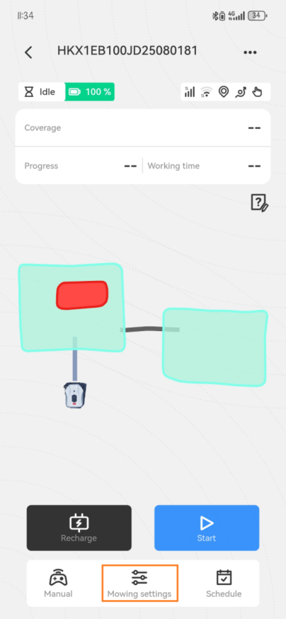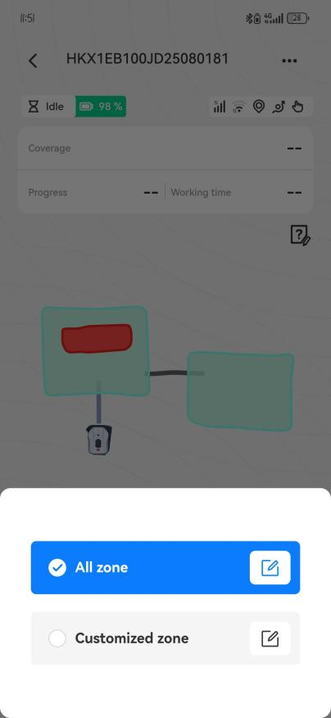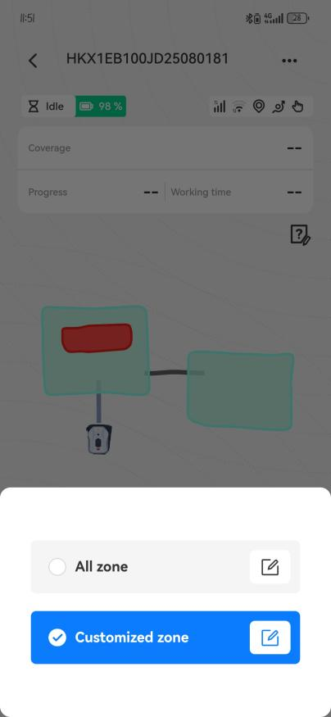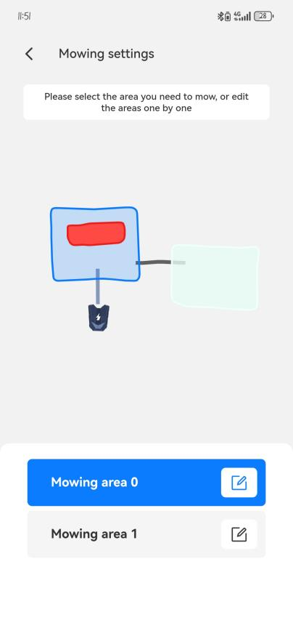

Mowing Angle Settings
(1) On the mowing settings page, scroll down to find the [Mowing Angle] settings section.
Mowing Angle: Refers to the angle between the exit direction of the charging station and the direction of the mowing trajectory.；
- Disable [Specified Angle]: For each task, the device will automatically calculate the optimal mowing angle.
- Enable [Specified Angle] — supports two modes：
- Automatic Switching: For each task, the device calculates the optimal mowing angle and applies a random offset ranging from -10° to +10.
- Custom: At the start of each new task, the device will automatically switch mowing angles in the sequence of the preset angle groups.
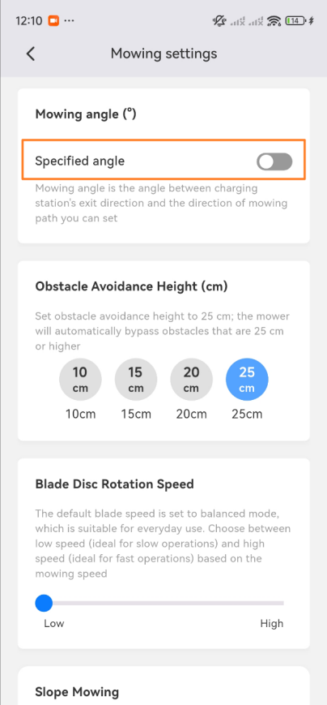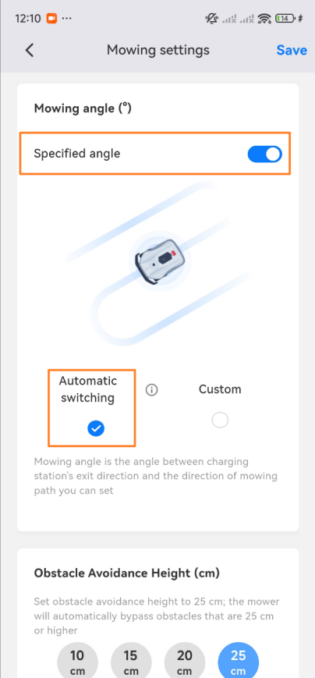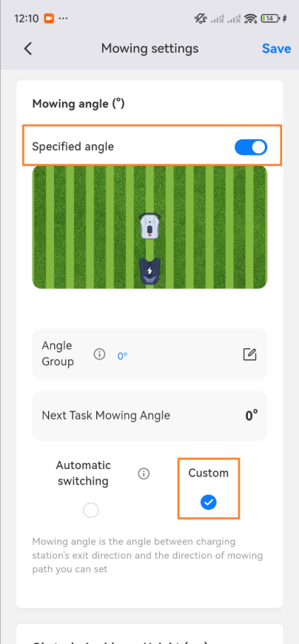
- Select [Custom] mode , Click【】after the button，Start editing mowing angle groups
- Adjust the angle slider to preview the effect in real-time within the angle preview window. Once you have selected a suitable angle, click the [+] button; multiple additions are supported.；
- If only a single angle is required, you may directly delete the default angle (0) after adding the target angle.°；
- Once editing is complete, click the [Confirm] button to temporarily save the mowing angle group and automatically return to the mowing settings page.
At this point, by referring to the angle preview image and the [Next Task Mowing Angle] field on the Mowing Settings page, you can view the estimated mowing angle for the device's next uninterrupted task.
- Save All Configurations
Once all parameters have been configured, click the [Save] button in the upper-right corner of the Mowing Settings page; upon confirming the save, the configuration will be successfully saved.
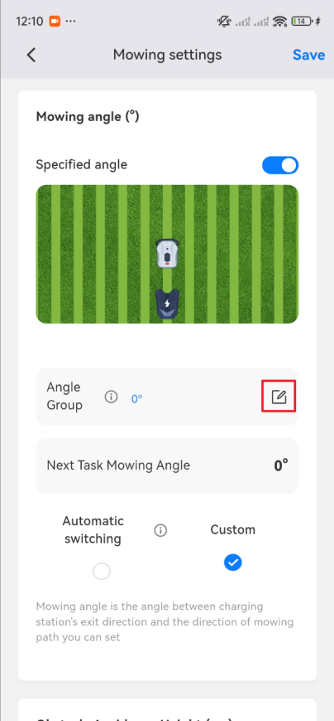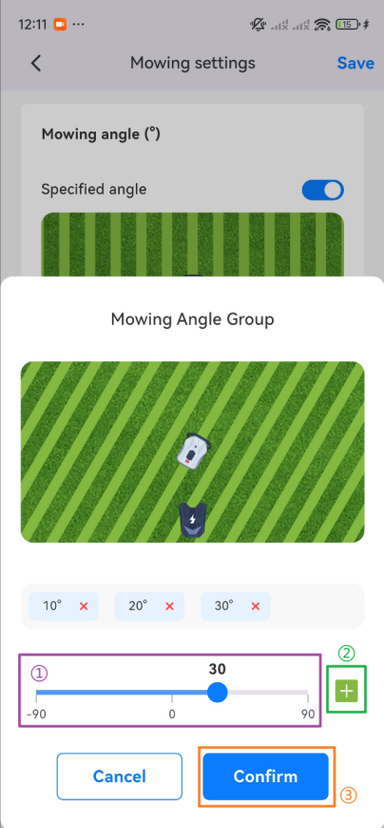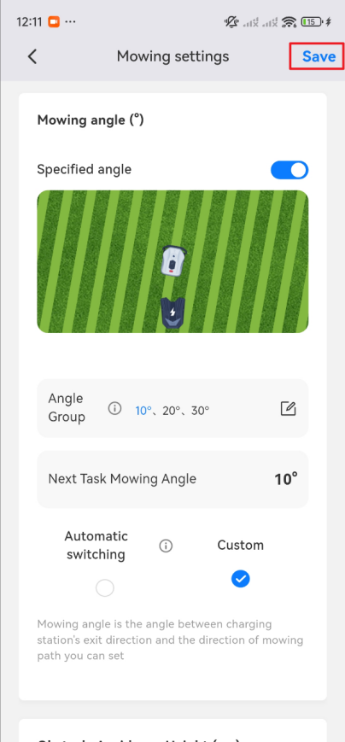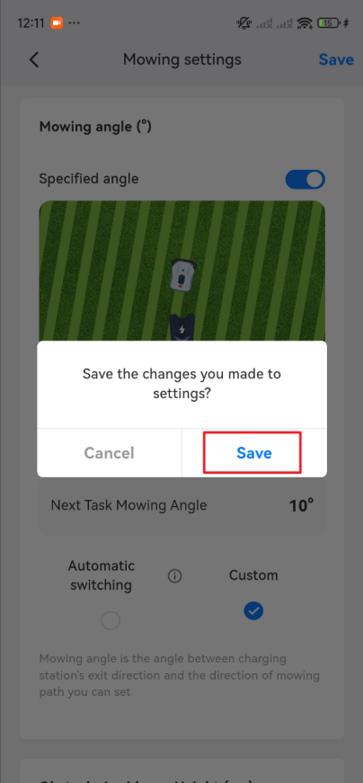

Exemplary Case Studies
Selected [Full Area] Application Mode: Enable [Specified Angles], set Angle Group to [10°, 20°, 30°].
The equipment successfully executed three mowing tasks without interruption; the angles for each zone are as follows:
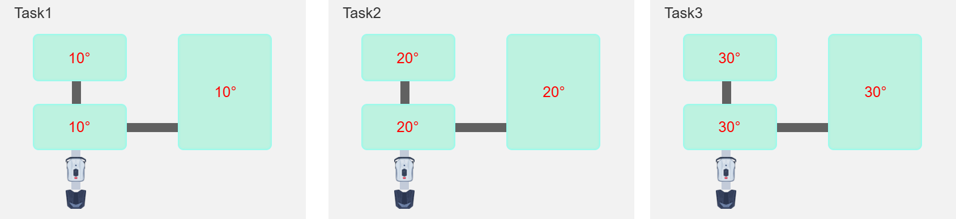

Selected [Custom Area] Application Mode:：
- Area A: Enable [Specified Angles], and set the angle group to [10°, 20°, 30°].
- Area B: Enable [Specified Angles], and set the angle group to [40°, 50°, 60°].
- Area C: Enable [Specified Angles], and set the angle group to [70°, 80°, 90°].
The equipment successfully executed three mowing tasks without interruption; the angles for each zone are as follows:
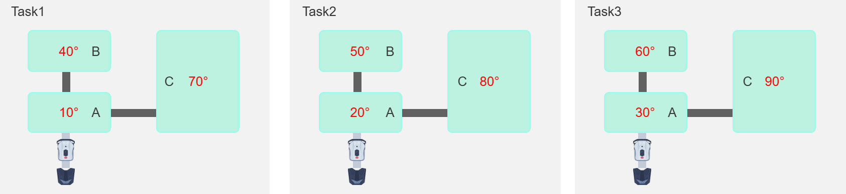
Note: Regardless of the selected parameter application mode, if a discontinuity is detected within the mowing area, the device will, by default, continue mowing in that specific area using the mowing angle from the previous task.

